Task 1.1
Parent and child tables created. Constraints applied.
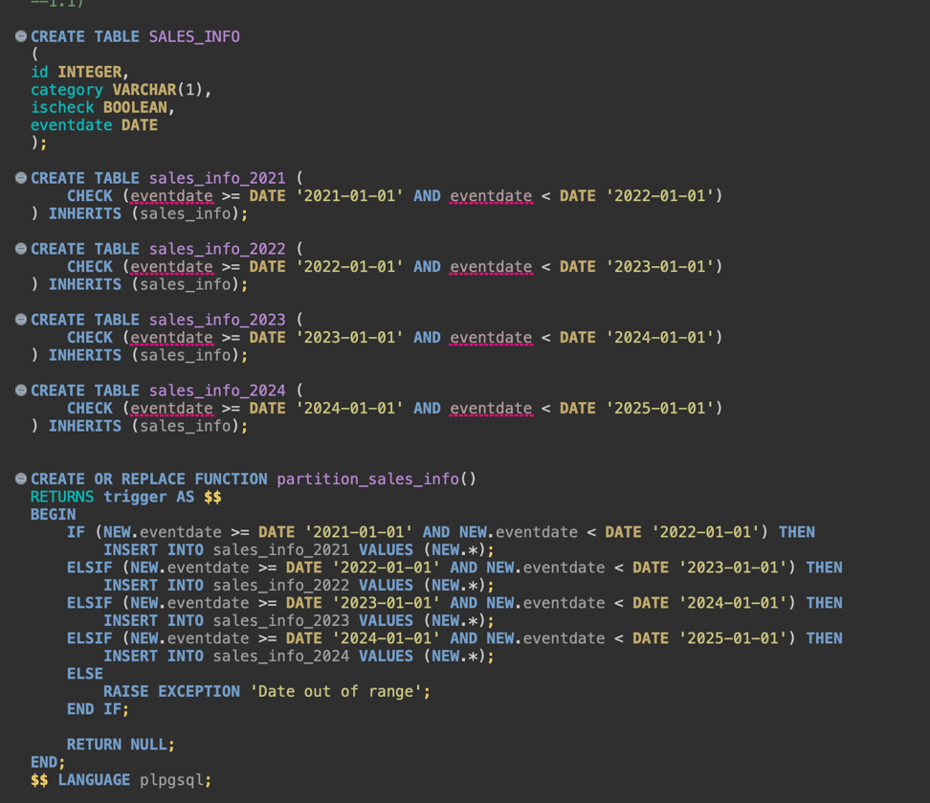
The trigger turns on the plpgsql function and sends the rows to the designated child tables.
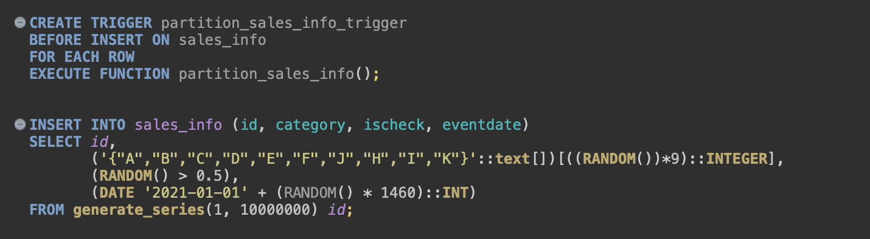
The rows are inserted into the child tables and not in the parent table.
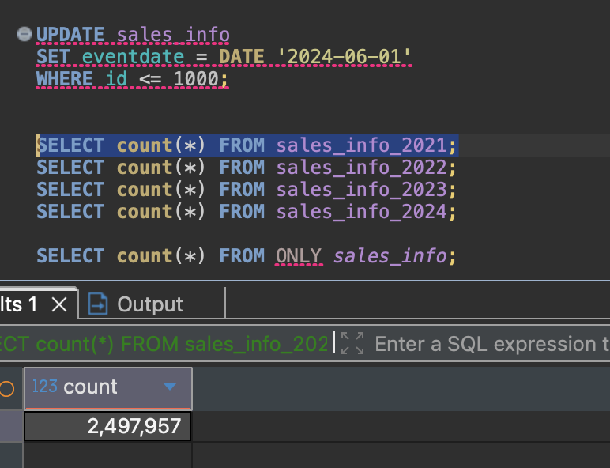
Updating, however can’t be done in a straightforward way. Rows have to be removed and reinserted elsewhere not to violate the check constraints. 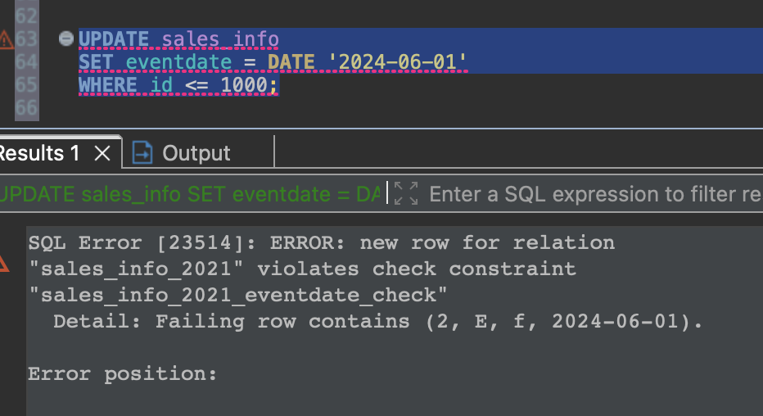
Separately non-partitioned table is created and same number and type of data is inserted.
Select *
Gives an append of 4 child tables for the partitioned parent table.
Gives a regular sequential scan for the non-partitioned table. The execution time is about half of the partitioned table.
Running select on a filtered range of 1 year however is faster on the partitioned table.
Same with finding an exact row – the partitioned table takes 134ms, non-partitioned table took 281ms.
We see that in case of partition only one child table gets scanned – the one containing the row.
-> Parallel Append (cost=0.00..26551.17 rows=2835 width=11) (actual time=1.414..105.253 rows=2307.67 loops=3)
Buffers: shared hit=564 read=12951
-> Parallel Seq Scan on sales_info_2023 sales_info_2 (cost=0.00..26537.00 rows=2834 width=11) (actual time=1.412..105.083 rows=2307.67 loops=3)
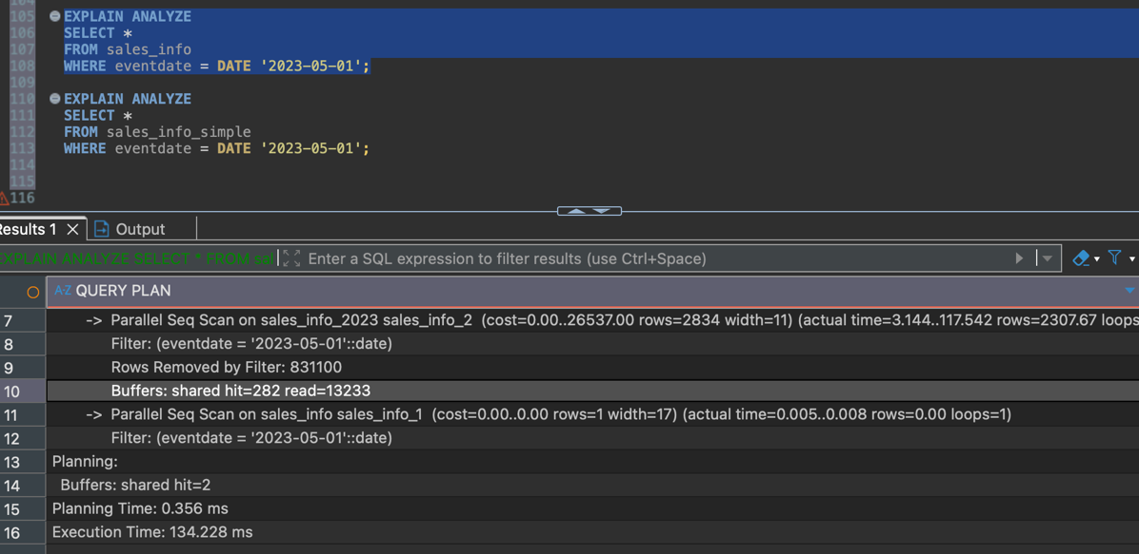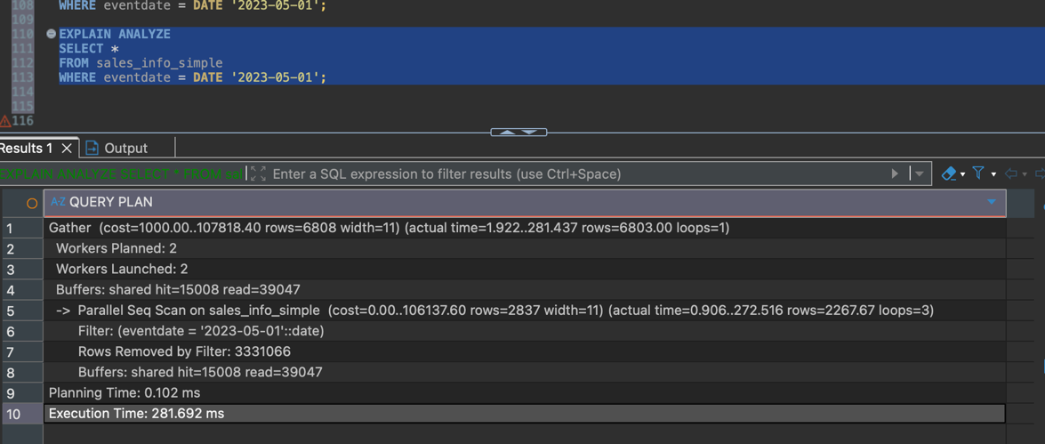
The execution time difference between the count(*) queries are not as large.
412ms for non-partitioned, 463 for the partitioned.
There was no pruning, as all the child tables contain data, all of them need to be scanned.
Finally, in case of the filtered count(*) the scan only applies to the filtered range
-> Parallel Seq Scan on sales_info_2022 sales_info_2 (cost=0.00..29110.71 rows=1040442 width=0) (actual time=0.588..62.643 rows=832518.00 loops=3)

A child table can be deleted a new table can be created instead of it with the same purpose. The function attached to the trigger will also have to be updated to contain the new child table and send the correct rows to it.
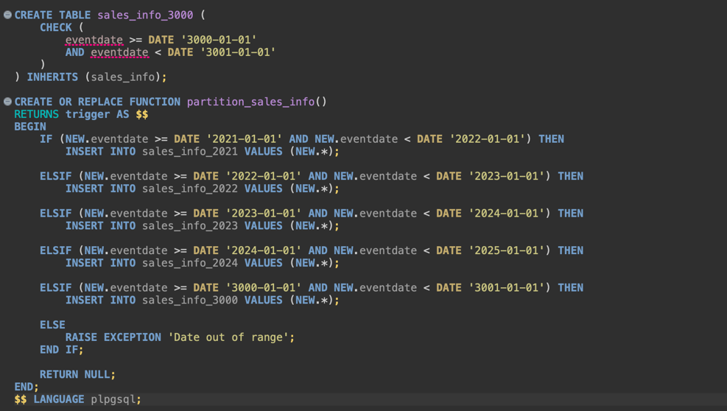

Task 1.2
Unlike with inheritance, the declarative partitioning does not necessitate a function to allocate the rows to the partitions.
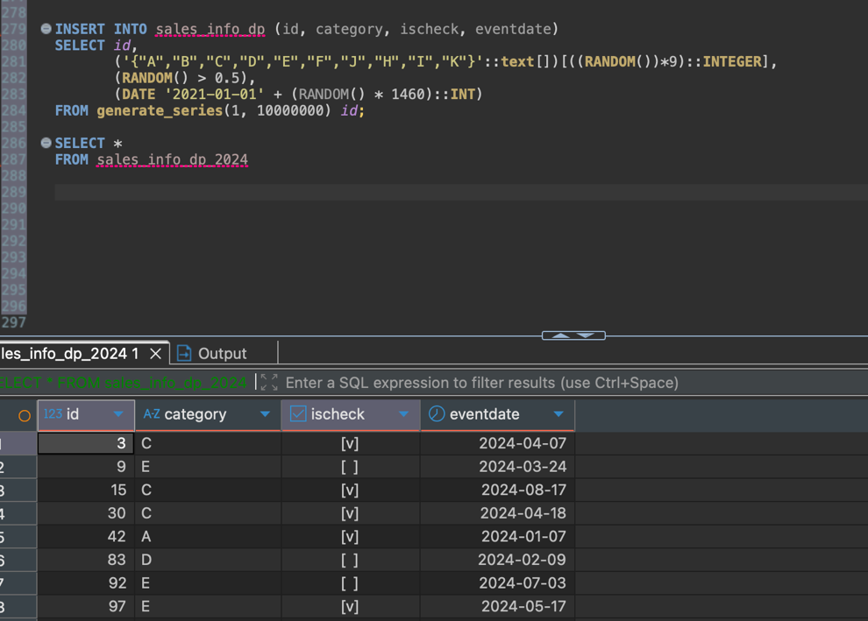
Unlike with inheritance, the are no unintended restrictions to make updates
UPDATE sales_info_dp
SET category = 'A'
WHERE id <= 1000;
Can be carried out.
Gives an append of all yearly partitions and their list partitions.
All subpartitions are scanned:
Execution time: 941ms
Non-partitioned table gives a simple sequential scan.
Execution time: 584ms
Partitioned table is slower for full scan.
Select with filtered range of one year
Only 2022 partitions are scanned:
sales_info_dp_2022_grp1
sales_info_dp_2022_grp2
sales_info_dp_2022_default
Execution time: 289ms
Non-partitioned table: 592ms
Partition pruning works on RANGE partition.
Execution time is about twice as fast.
Select exact date
Only 2023 partitions are scanned:
sales_info_dp_2023_grp1
sales_info_dp_2023_grp2
sales_info_dp_2023_default
Execution time: 84ms
Non-partitioned table: 312ms
Only one yearly partition is accessed.
Significant improvement.

Select exact category
Only grp1 partitions are scanned across all years:
sales_info_dp_2021_ab
sales_info_dp_2022_grp1
sales_info_dp_2023_grp1
sales_info_dp_2024_grp1
Execution time: 344ms
Non-partitioned table: 535ms
LIST partition pruning works correctly.

Count(*)
All partitions are scanned.
No pruning possible.
Execution time comparable to non-partitioned table.
Partitioning does not improve full table aggregation.
Count with filtered range
Only partitions within the specified year are scanned.
Pruning applies on RANGE level.
Execution time significantly better than non-partitioned table.

and final subtask of 1.2:
One list partition inside a yearly partition is split into two.
The original partition containing ('A','B','C','D','E') is detached.
Two smaller partitions are created instead:
('A','B','C') and ('D','E').
Data is inserted back and automatically routed into the correct new partitions.
The old partition is dropped.
After that, the structure is restored.
The two smaller partitions are removed and the original
('A','B','C','D','E') partition is recreated.
This shows that partitions can be reorganized, but data has to be moved manually.

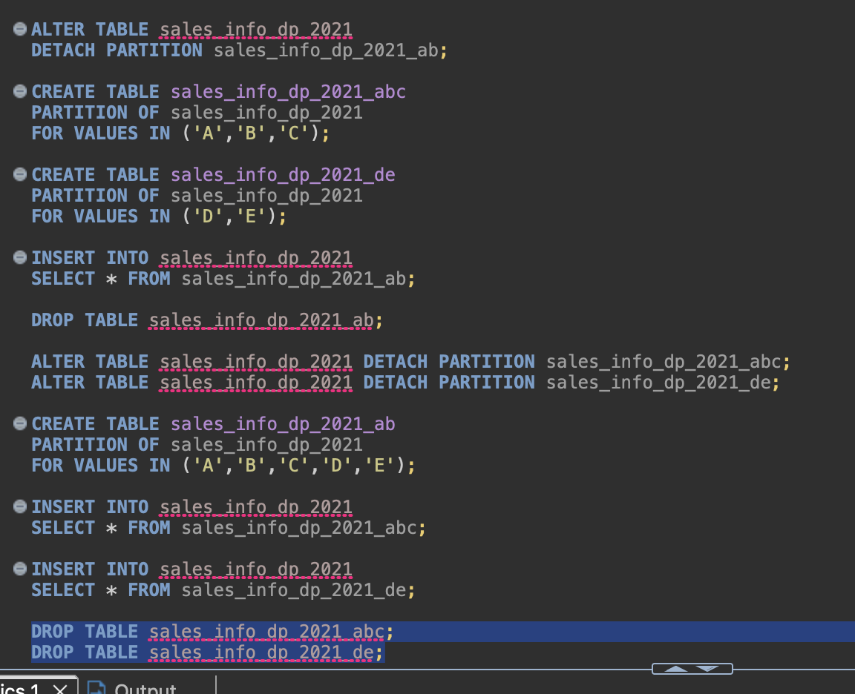

Task 2.1
Parallel workers were enabled. Plans were analyzed for SALES_INFO_DP.
Select *
Gives an Append over all subpartitions. Every yearly and list partition is scanned.
Execution time is 964ms. No pruning occurs.
-> Append
-> Seq Scan on sales_info_dp_2021_ab
-> Seq Scan on sales_info_dp_2022_grp1
-> Seq Scan on sales_info_dp_2023_grp1
ORDER BY eventdate
Adds a global Sort on top of the Append.
Sort Method: external merge Disk: 215MB
Execution time increases to 3140ms.
All partitions are scanned and then sorted together.
COUNT(*)
Uses parallel aggregation.
-> Finalize Aggregate
-> Gather
Workers Planned: 3
-> Partial Aggregate
-> Parallel Append
Execution time is 324ms.
Parallelism improves aggregation, but all partitions are still scanned.
COUNT(*) with range of dates
Only 2022 partitions are scanned. Range pruning works correctly.
Execution time is 153ms.
-> Parallel Append
-> Parallel Seq Scan on sales_info_dp_2022_grp1
-> Parallel Seq Scan on sales_info_dp_2022_grp2
-> Parallel Seq Scan on sales_info_dp_2022_default
JOIN on exact date
Parallel Hash Join is used.
Partition pruning works on the inheritance table for 2023.
-> Parallel Hash Join
Hash Cond: (d.id = s.id)
Execution time is 458ms.
Parallel execution is applied both to scanning and joining.
Parallel workers improve aggregation and join performance.
Range filtering reduces scanned partitions.
Full scans still require scanning all partitions.
Sorting removes most of the partitioning advantage due to global merge.
Indexes were added on eventdate and category for SALES_INFO_DP. PostgreSQL created corresponding indexes on all partitions.
Exact date query now uses Bitmap Index Scan instead of Seq Scan. Only 2023 partitions are accessed. Execution time drops to 34ms.
-> Bitmap Index Scan on sales_info_dp_2023_grp1_eventdate_idx
Index Cond: (eventdate = '2023-05-01'::date)
Exact category query switches to Bitmap Index Scan on list partitions. Sequential scans are avoided, but multiple yearly partitions are still accessed. Execution time is 358ms.
-> Bitmap Index Scan on sales_info_dp_2023_grp1_category_idx
Index Cond: ((category)::text = 'A'::text)
Date + category query benefits the most. Only one yearly partition is accessed and both indexes are combined using BitmapAnd. Execution time drops to 15ms.
-> BitmapAnd
-> Bitmap Index Scan on sales_info_dp_2023_grp1_eventdate_idx
-> Bitmap Index Scan on sales_info_dp_2023_grp1_category_idx
Indexes significantly improve selective queries. Partition pruning limits partitions, and indexes limit rows inside partitions. Full scans remain unaffected.

